**How to Create an Entity Relationship Diagram (ERD)**

Below points show how to go about creating an ER diagram.

1. **Identify all the entities** in the system. An entity should appear only once in a particular diagram. Create rectangles for all entities and name them properly.
2. **Identify relationships between entities**. Connect them using a line and add a diamond in the middle describing the relationship.
3. **Add attributes for entities**. Give meaningful attribute names so they can be understood easily.

[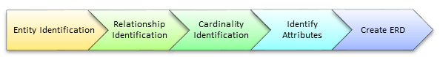](https://www.guru99.com/images/1/100518_0621_ERDiagramTu13.png)

Steps to Create an ER Diagram

**Some examples of ER model are −**

1. **Hospital ER Model**

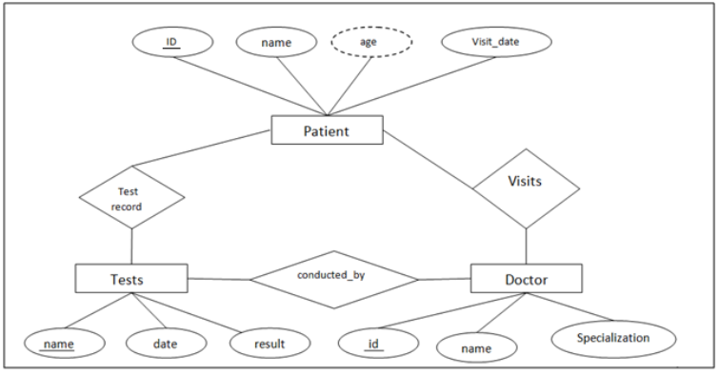

This is an ER model of a Hospital. The entities are represented in rectangular boxes and are Patient, Tests and Doctor.

Each of these entities have their respective attributes which are −

* Patients - ID(primary key), name, age, visit_date
* Tests- Name(primary key), date, result
* Doctor- ID(primary key), name, specialization

The relationships between different entities are represented by a diamond shaped box.

1. **Company ER Model**

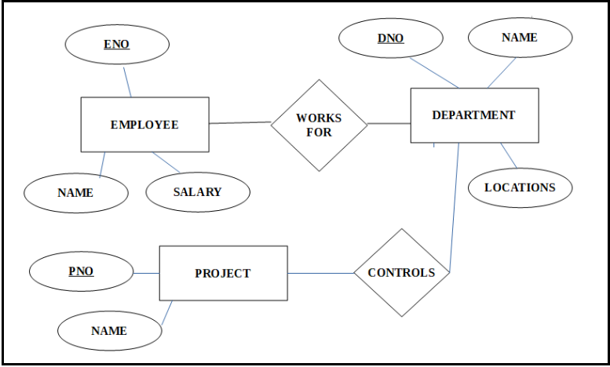

The entities in this ER model are Employee, Department and Project. These entities have the following attributes −

* Employee - ENO(Primary Key) , Name, Salary
* Department - DNO(Primary key), Name, Locations
* Project - PNO(Primary key), Name

The relationships in this ER model are represented as Works for and Controls.

1. **Suppose you are given the following requirements for a simple database for the National Hockey League (NHL):**

* **the NHL has many teams,**
* **each team has a name, a city, a coach, a captain, and a set of players,**
* **each player belongs to only one team,**
* **each player has a name, a position (such as left wing or goalie), a skill level, and a set of injury records,**
* **a team captain is also a player,**
* **a game is played between two teams (referred to as host_team and guest_team) and has a date (such as May 11th, 1999) and a score (such as 4 to 2).**

**Construct a clean and concise ER diagram for the NHL database using the Chen notation as in your textbook. List your assumptions and clearly indicate the cardinality mappings as well as any role indicators in your ER diagram.**

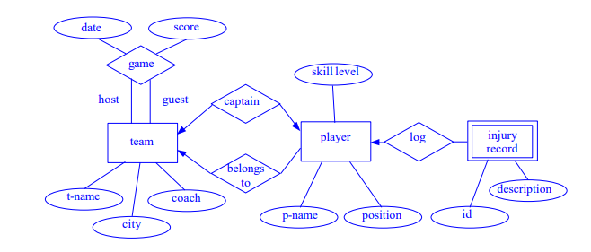

**4. A salesperson may manage many other salespeople. A salesperson is managed by only one salespeople. A salesperson can be an agent for many customers. A customer is managed by one salespeople. A customer can place many orders. An order can be placed by one customer. An order lists many inventory items. An inventory item may be listed on many orders. An inventory item is assembled from many parts. A part may be assembled into many inventory items. Many employees assemble an inventory item from many parts. A supplier supplies many parts. A part may be supplied by many suppliers.**

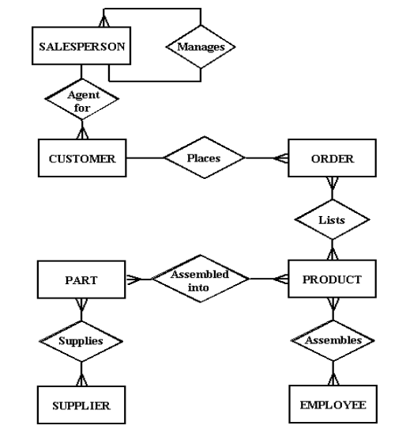

**5. In a university, a Student enrols in Courses. A student must be assigned to at least one or more Courses. Each course is taught by a single Professor. To maintain instruction quality, a Professor can deliver only one course**

**Step 1) Entity Identification**

We have three entities

* Student
* Course
* Professor

[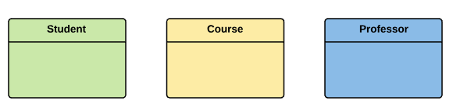](https://www.guru99.com/images/1/100518_0621_ERDiagramTu14.png)

**Step 2) Relationship Identification**

We have the following two relationships

* The student is assigned a course
* Professor delivers a course

[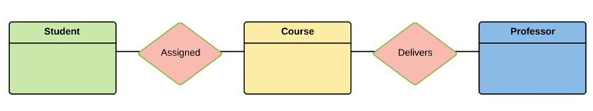](https://www.guru99.com/images/1/100518_0621_ERDiagramTu15.png)

**Step 3) Cardinality Identification**

For them problem statement we know that,

* A student can be assigned multiple courses
* A Professor can deliver only one course

[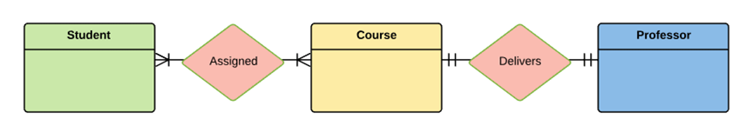](https://www.guru99.com/images/1/100518_0621_ERDiagramTu16.png)

**Step 4) Identify Attributes**

You need to study the files, forms, reports, data currently maintained by the organization to identify attributes. You can also conduct interviews with various stakeholders to identify entities. Initially, it's important to identify the attributes without mapping them to a particular entity.

Once, you have a list of Attributes, you need to map them to the identified entities. Ensure an attribute is to be paired with exactly one entity.

Once the mapping is done, identify the primary Keys. If a unique key is not readily available, create one.

|  |  |  |
| --- | --- | --- |
| **Entity** | **Primary Key** | **Attribute** |
| Student | Student_ID | StudentName |
| Professor | Employee_ID | ProfessorName |
| Course | Course_ID | CourseName |

[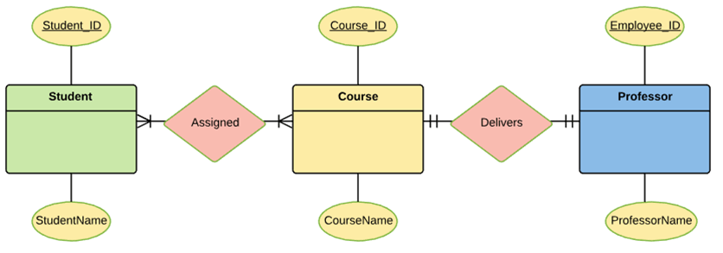](https://www.guru99.com/images/1/100518_0621_ERDiagramTu17.png)

For Course Entity, attributes could be Duration, Credits, Assignments, etc. For the sake of ease, we have considered just one attribute.

**Step 5) Create the ERD Diagram**

A more modern representation of Entity Relationship Diagram Example

[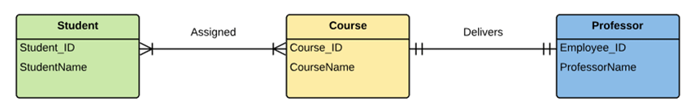](https://www.guru99.com/images/1/100518_0621_ERDiagramTu18.png)

* **Best Practices for Developing Effective ER Diagrams**

Here are some best practice or example for Developing Effective ER Diagrams.

* Eliminate any redundant entities or relationships
* You need to make sure that all your entities and relationships are properly labelled
* There may be various valid approaches to an ER diagram. You need to make sure that the ER diagram supports all the data you need to store
* You should assure that each entity only appears a single time in the ER diagram
* Name every relationship, entity, and attribute are represented on your diagram
* Never connect relationships to each other
* You should use colours to highlight important portions of the ER diagram

**6. Assume we have the following application that models soccer teams, the games they play, and the players in each team. In the design, we want to capture the following:**

* **We have a set of teams, each team has an ID (unique identifier), name, main stadium, and to which city this team belongs.**
* **Each team has many players, and each player belongs to one team. Each player has a number (unique identifier), name, DoB, start year, and shirt number that he uses.**
* **Teams play matches, in each match there is a host team and a guest team. The match takes place in the stadium of the host team.**
* **For each match we need to keep track of the following:**
* **The date on which the game is played**
* **The final result of the match**
* **The players participated in the match. For each player, how many goals he scored,**
* **whether or not he took yellow card, and whether or not he took red card.**
* **During the match, one player may substitute another player. We want to capture this substitution and the time at which it took place.**
* **Each match has exactly three referees. For each referee we have an ID (unique identifier), name, DOB, years of experience. One referee is the main referee and the other two are assistant referee.**

**Design an ER diagram to capture the above requirements. State any assumptions you have that affects your design (use the back of the page if needed). Make sure cardinalities and primary keys are clear.**

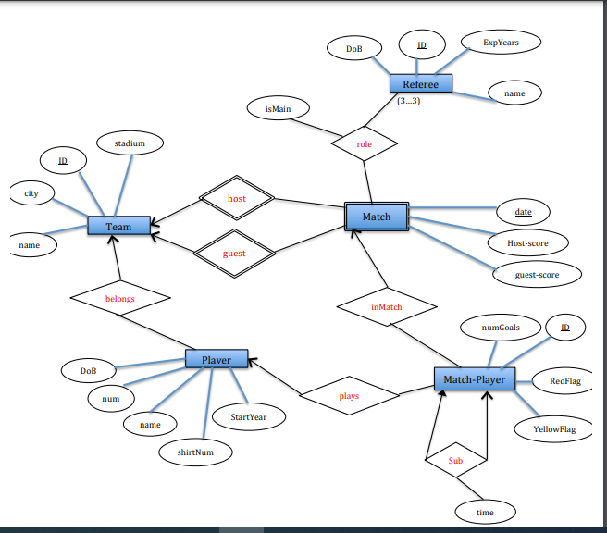

**Assumptions:**

* In Match- Player entity set, we added a unique identifier for each record ID.
* The final result in Match entity set is captured using two attributes Host- score and guest- score.
* The attribute ‘isMain’ in relationship ‘role’ is true if the referee is the main referee in the match, otherwise, it will be false.